**DBMS Project**

**Final Report**

**Group Members:**

|  |  |  |  |
| --- | --- | --- | --- |
| **No.** | **Name** | **Roll Number** | **Batch Number** |
| 1. | Pragya Datt | BT17GCS077 | B4 |
| 2. | Rupali Vyas | BT17GCS091 | B4 |
| 3 | Sanya Kapoor | BT17GCS098 | B4 |
| 4 | Pragya Kapoor | BT17GCS078 | B4 |
| 5 | Shaurya Srivastava | BT17GCS100 | B4 |

Project Title:

‘Pizza n Chill’

Relation Definitions and conversion into 3NF:

1) Department

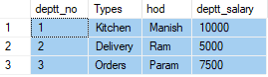

‘HOD’ and the ‘department salary’ can be derived from ‘types’ as well as the primary key, ‘department number’. This table design is non-3NF compliant, and could, therefore, result in data anomalies.

Moving the additional dependent column to another table and referencing it using a foreign key would make it compliant. This would result in two tables:

In the **Department table** below, ‘typeid’ is a foreign key to the **Types table**:

* Deptt_no
* Hod
* Deptt_salary
* Typeid

The new **Types table** will be as follows:

* Typeid
* Types
* Hod
* Deptt_salary

2) Customer

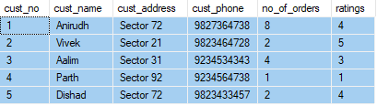

All other attribites can be derived from ‘cust_phone’ as well as the primary key, ‘cust_no’. This table design is non-3NF compliant, and could, therefore, result in data anomalies.

Moving the additional dependent column to another table and referencing it using a foreign key would make it compliant. This would result in two tables:

In the **Customer table** below, ‘cust_phone_id’ is a foreign key to the **Phone table**:

* Cust_no
* Cust_name
* Cust_address
* No_of_orders
* Ratings
* Cust_phone_id

The new **Phone table** will be as follows:

* Cust_phone_id
* Cust_phone
* Cust_name
* Cust_address
* No_of_orders
* Ratings

3) Branches

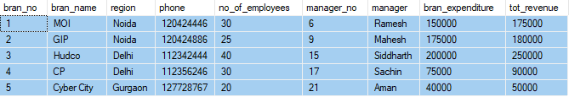

All other attributes can be derived from ‘phone’, ‘manager_no’ as well as the primary key, ‘bran_no’. This table design is non-3NF compliant, and could, therefore, result in data anomalies.

Moving the additional dependent columns to another table and referencing them using a foreign key would make it compliant. This would result in three tables:

In the **Branches table** below, ‘phone_id’ and ‘manager_id’ are foreign keys to the **Phone table** and **Manager table**:

* Bran_no
* Bran_name
* Region
* No_of_employees
* Manager
* Bran_expenditure
* Tot_revenue
* Phone_id
* Manager_id

The new **Phone table** will be as follows:

* Phone_id
* Phone
* Bran_name
* Region
* No_of_employees
* Bran_expenditure
* Tot_revenue

The new **Manager table** will be as follows:

* Manager_id
* Manager
* Bran_name
* Region
* No_of_employees
* Bran_expenditure
* Tot_revenue

4) Employees

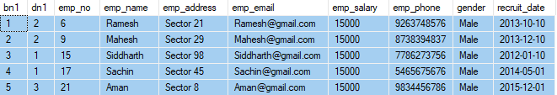

All other attributes can be derived from ‘bn1’, ‘emp_phone’ as well as the primary key, ‘emp_no’. This table design is non-3NF compliant, and could, therefore, result in data anomalies.

Moving the additional dependent columns to another table and referencing them using a foreign key would make it compliant. This would result in three tables:

In the **Employees table** below, ‘bn_id’ and ‘phone_id’ are foreign keys to the **Bn table** and **Phone table**:

* Dn1
* Emp_no
* Emp_name
* Emp_address
* Emp_email
* Emp_salary
* Gender
* Recruitment_date
* Phone_id
* Bn_id

The new **Bn table** will be as follows:

* Bn_id
* Dn1
* Emp_name
* Emp_address
* Emp_email
* Emp_salary
* Gender
* Recruitment_date

The new **Phone table** will be as follows:

* Phone_id
* Dn1
* Emp_name
* Emp_address
* Emp_email
* Emp_salary
* Gender
* Recruitment_date

5) Orders

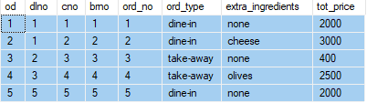

Already in 3NF because it is in 2NF (no PFD) and there does not exist any non-prime attribute that determines another non-prme attribute.

6) Employee_Work_Hrs

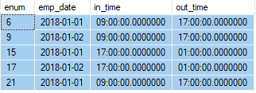

Already in 3NF because it is in 2NF (no PFD) and there does not exist any non-prime attribute that determines another non-prme attribute.

7) Food_Items

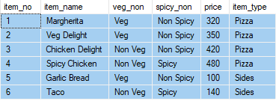

Already in 3NF because it is in 2NF (no PFD) and there does not exist any non-prime attribute that determines another non-prme attribute.

8) Ingredients

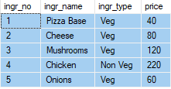

Already in 3NF because it is in 2NF (no PFD) and there does not exist any non-prime attribute that determines another non-prme attribute.

9) Inventory

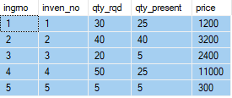

Was not in 3NF. Was converted and we obtained the same table. Thus, this is a case of BCNF and therefore, a violating FD will exist.

10) Deliveries

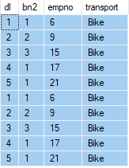

Already in 3NF because it is in 2NF (no PFD) and there does not exist any non-prime attribute that determines another non-prme attribute.

11) Deals

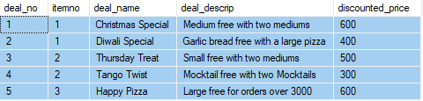

All other attributes can be derived from ‘deal_name’ as well as the primary key, ‘deal_no’. This table design is non-3NF compliant, and could, therefore, result in data anomalies.

Moving the additional dependent column to another table and referencing it using a foreign key would make it compliant. This would result in two tables:

In the **Deal table** below, ‘dnameid’ is a foreign key to the **DName table**:

* Deal_no
* Item_no
* Deal_descrip
* Discounted_price
* Dnameid

The new **DName table** will be as follows:

* Dnameid
* Deal_name
* Item_no
* Deal_descrip
* Discounted_price

12) Logistics

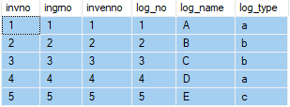

Was not in 3NF. Was converted and we obtained the same table. Thus, this is a case of BCNF and therefore, a violating FD will exist.

13) Finance

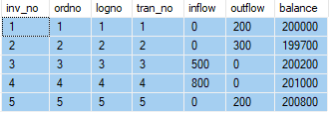

Was not in 3NF. Was converted and we obtained the same table. Thus, this is a case of BCNF and therefore, a violating FD will exist.

14) Complaints

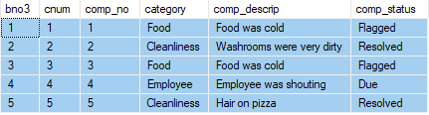

Already in 3NF because it is in 2NF (no PFD) and there does not exist any non-prime attribute that determines another non-prme attribute.

15) Have



Already in 3NF because it is in 2NF (no PFD) and there does not exist any non-prime attribute that determines another non-prme attribute.

16) Requires

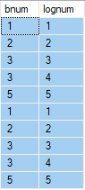

Already in 3NF because it is in 2NF (no PFD) and there does not exist any non-prime attribute that determines another non-prme attribute.

17) CompriseOf



Already in 3NF because it is in 2NF (no PFD) and there does not exist any non-prime attribute that determines another non-prme attribute.

18) Req

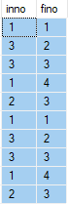

Already in 3NF because it is in 2NF (no PFD) and there does not exist any non-prime attribute that determines another non-prme attribute.

19) Deptt_Delivery



Already in 3NF because it is in 2NF (no PFD) and there does not exist any non-prime attribute that determines another non-prme attribute.

20) Deptt_Kitchen



Already in 3NF because it is in 2NF (no PFD) and there does not exist any non-prime attribute that determines another non-prme attribute.

21) Deptt_Orders



Already in 3NF because it is in 2NF (no PFD) and there does not exist any non-prime attribute that determines another non-prme attribute.